LAB No 11
Implementation of Fuzzy C means Clustering
Fuzzy C-Means (FCM) clustering is an unsupervised soft-clustering technique that assigns data points to multiple clusters with varying degrees of membership, making it ideal for handling overlapping or uncertain data. In this practice program, students implement FCM in Python to generate clusters, analyze membership values, visualize results, and compare its performance with traditional hard-clustering methods like K-means.

Install Required libraries
pip install scikit-fuzzy

Question No. 1
Task:
Generate a synthetic 2-dimensional dataset consisting of three clusters. Apply Fuzzy C-Means clustering and analyze the results.
Questions:
- Generate a 2D dataset with three groups of points using Gaussian noise.
- Apply Fuzzy C-Means (FCM) clustering using skfuzzy with 3 clusters.
- Plot the clustered data points and cluster centers.
- Display the membership values for any 5 randomly selected points.
- Compute and interpret the Fuzzy Partition Coefficient (FPC).
- Compare the results with K-means clustering.
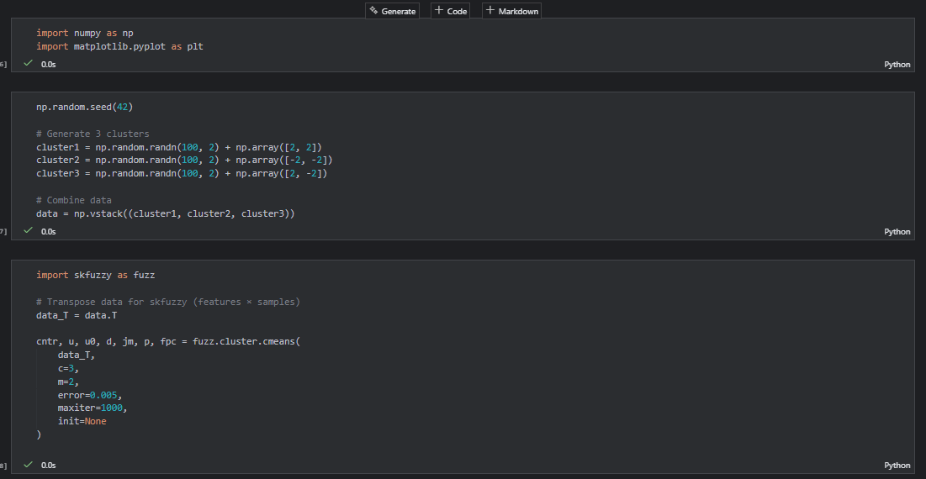
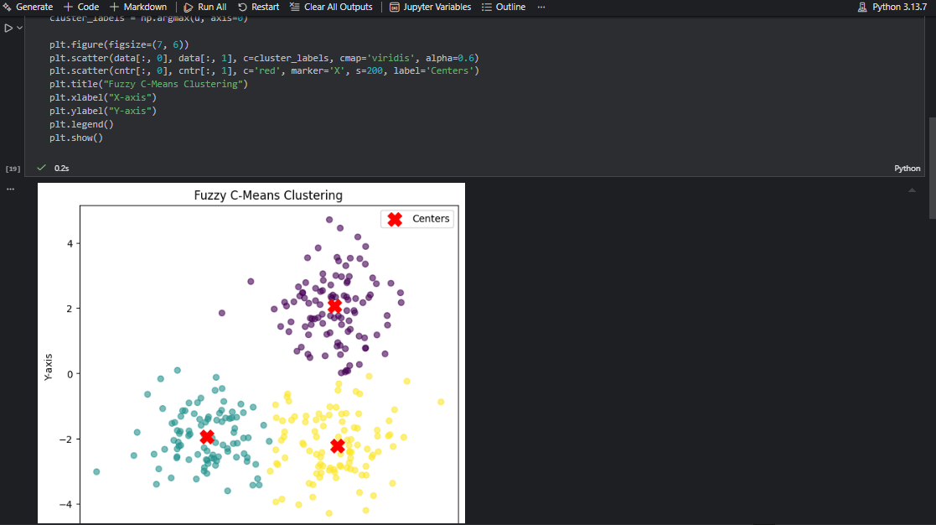
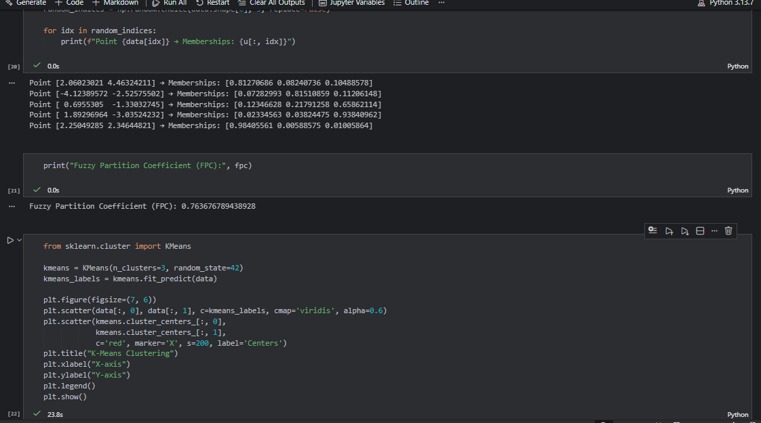
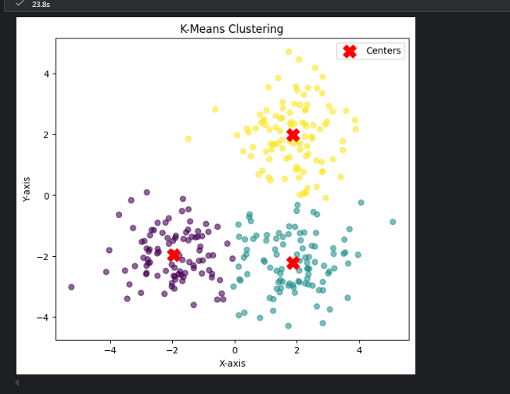
- Explain why FCM is more suitable for overlapping clusters than K-means.
Answer:
Fuzzy C-Means (FCM) is more suitable for overlapping clusters because it uses soft clustering, where each data point is assigned a degree of membership to all clusters rather than being assigned to only one cluster. This allows FCM to effectively handle uncertainty and overlap between clusters by representing partial belonging.
In contrast, K-Means uses hard clustering, where each data point belongs to exactly one cluster. This rigid assignment can lead to incorrect clustering when cluster boundaries overlap, as points near the boundaries are forced into a single cluster.
Therefore, FCM provides a more flexible and realistic clustering approach for overlapping data, making it superior to K-Means in scenarios involving ambiguous or uncertain cluster boundaries.
Question No. 2
Task:
Use the Iris dataset to cluster samples into 3 fuzzy classes and compare them with the actual species labels.
Questions:
- Load the Iris dataset from sklearn.
- Apply normalization and then use FCM to form 3 clusters.
- Identify the predicted cluster for the first 20 samples.
- Compare the predicted clusters with the actual labels.
- Compute the accuracy of FCM (use majority-mapping method).
- Report the FPC value and explain what it indicates about cluster quality.
- Compare FCM results with K-means clustering on the same dataset.
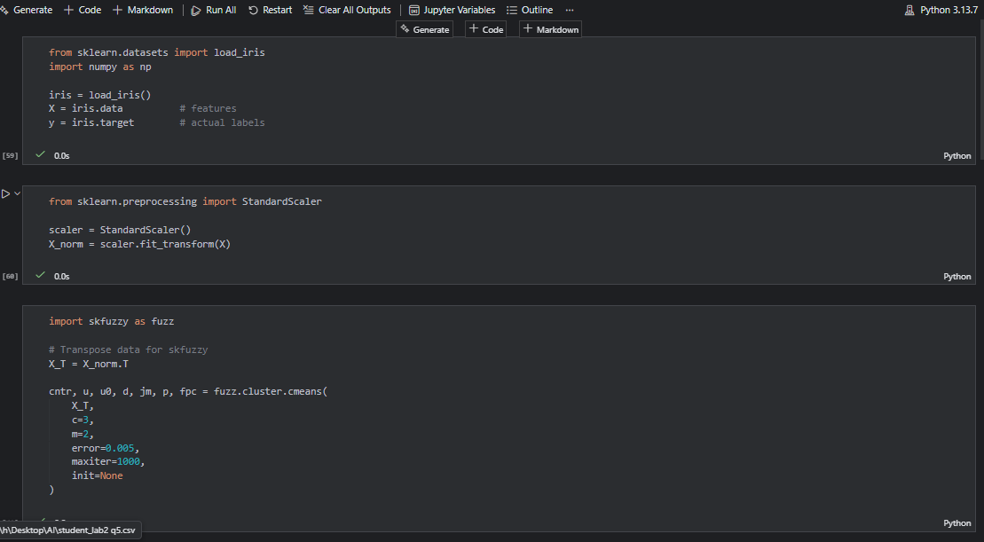
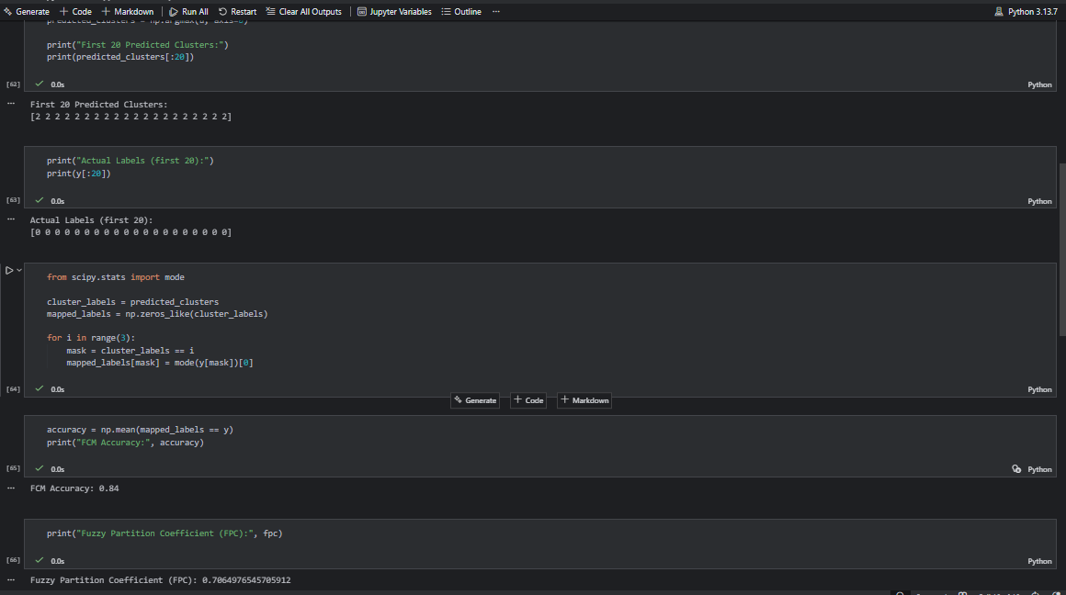
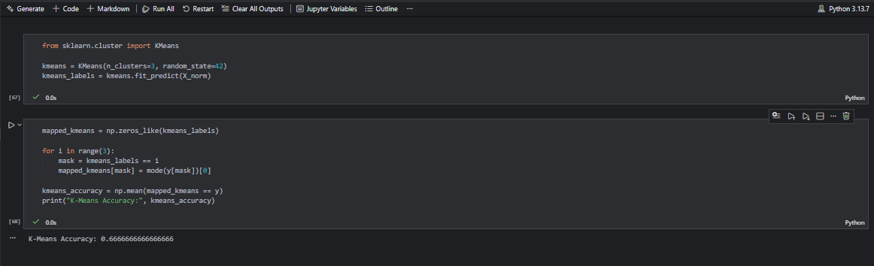

Question No. 3
Task:
Segment a grayscale image into meaningful regions using fuzzy clustering.
Questions:
- Load any grayscale image (or the one provided by the teacher).
- Convert the image into a 1D pixel array.
- Apply Fuzzy C-Means clustering to segment the image into three clusters.
- Reconstruct the segmented image and display it.
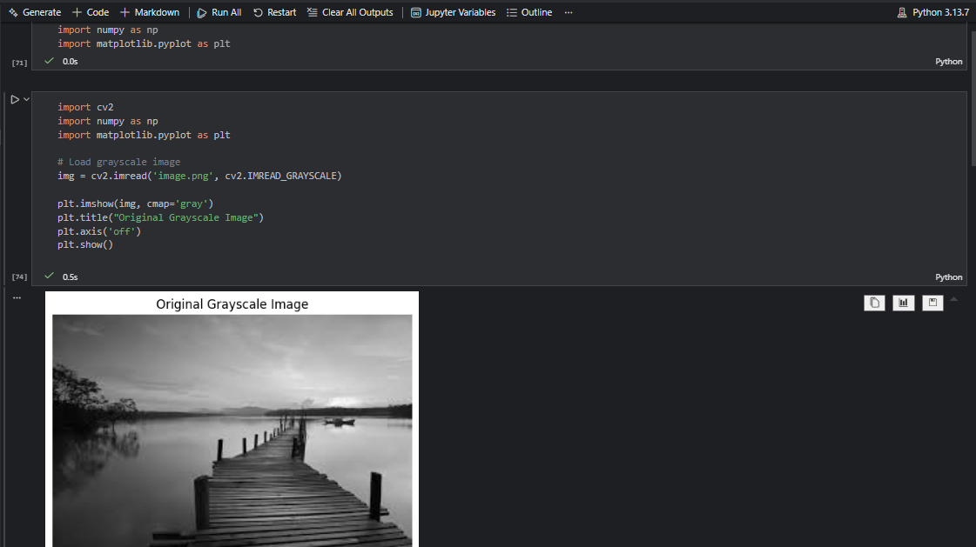
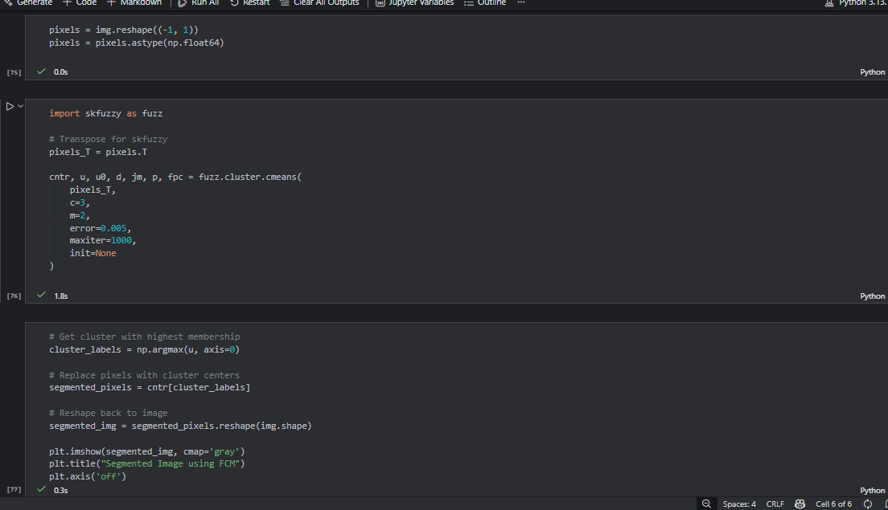
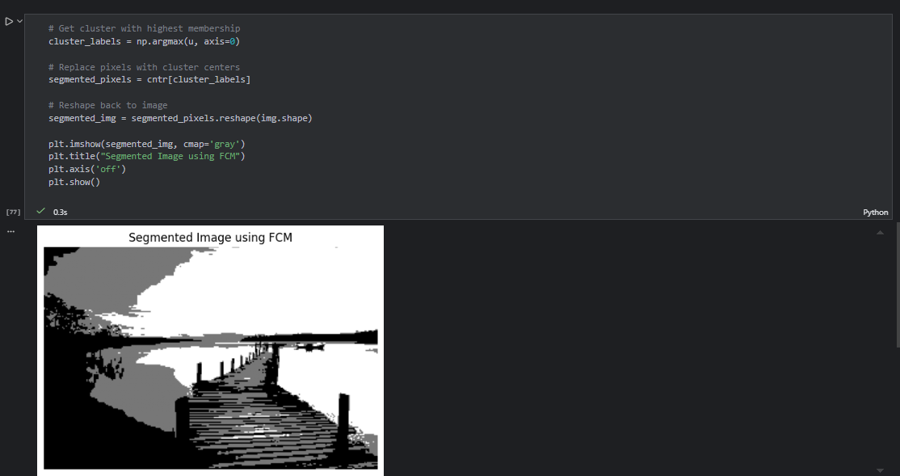
- Explain how pixel membership values differ across regions.
Answer:
In Fuzzy C-Means segmentation, each pixel is assigned a membership value for every cluster instead of a hard label. Pixels in homogeneous regions (clear dark or bright areas) show high membership for a single cluster. However, pixels near edges or boundaries exhibit distributed membership values across multiple clusters, representing uncertainty. This allows FCM to produce smoother transitions between regions compared to hard segmentation methods.

- Compare your segmented image with segmentation from thresholding or K-means.
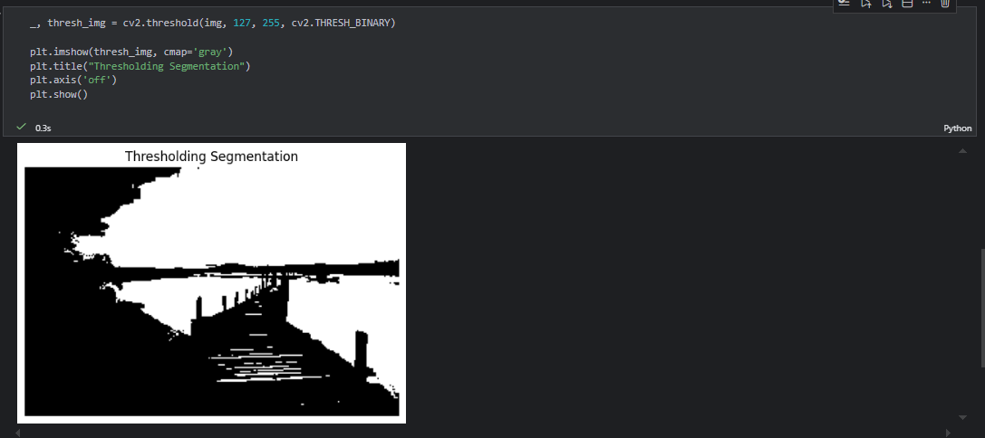
- Discuss how changing the number of clusters (c = 2, 4, 5) affects segmentation quality.
Answer:

Effect of changing number of clusters (c = 2, 4, 5)
- c = 2:
Image is over-simplified; important details may be lost.
- c = 3:
Balanced segmentation; main regions clearly separated.
- c = 4 or 5:
Finer segmentation; captures subtle intensity variations but may introduce noise and over-segmentation.
Optimal number of clusters depends on image complexity and application requirements.

Question No. 4
Task:
Perform market segmentation on a small customer dataset using Fuzzy C-Means clustering.
Dataset Fields:
- Age
- Income
- Spending Score
Questions:
- Create or load the given dataset of 10–20 customers.
- Normalize the features using MinMaxScaler.
- Apply FCM to generate 3 customer clusters.
- Assign each customer to the cluster with maximum membership.
- Display the membership matrix and cluster centers.
- Interpret each cluster (e.g., high income–low spending).
- Compare the results with K-means segmentation and justify whether FCM is better.
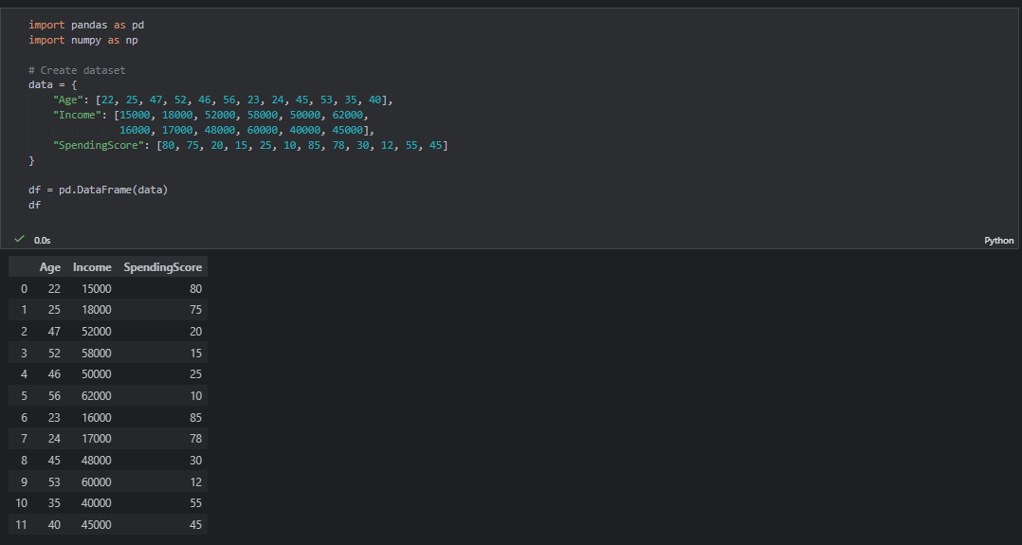
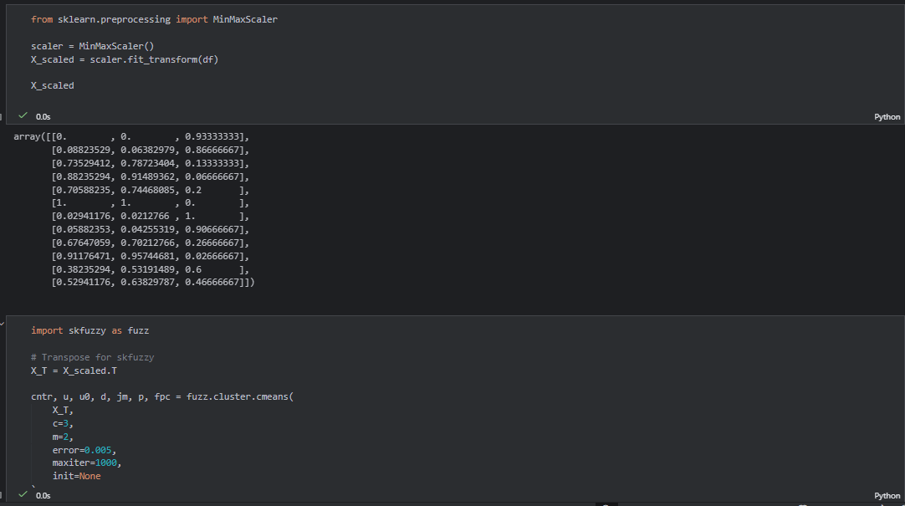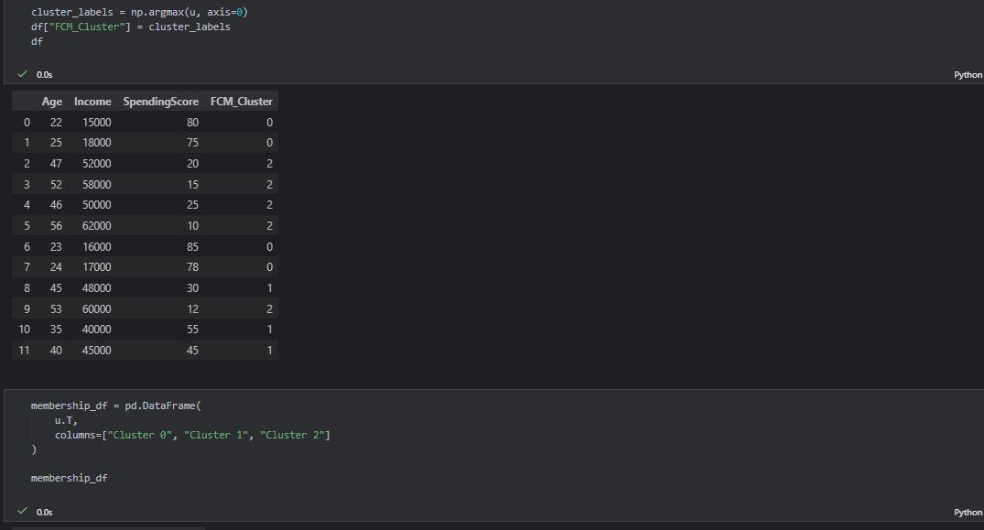
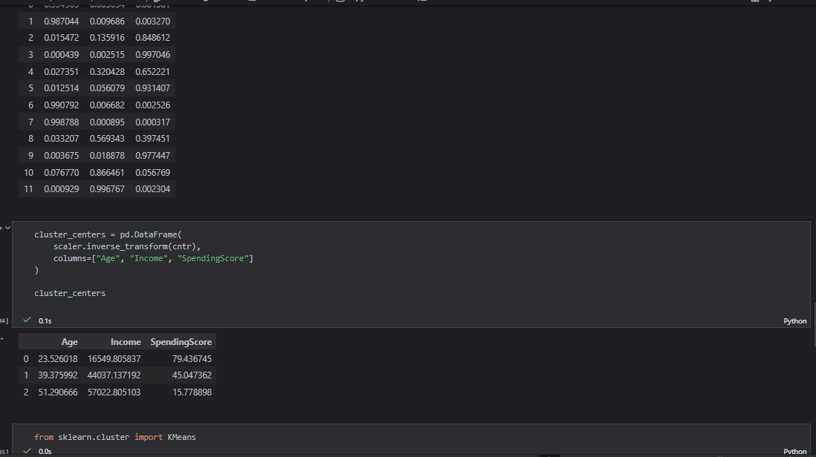
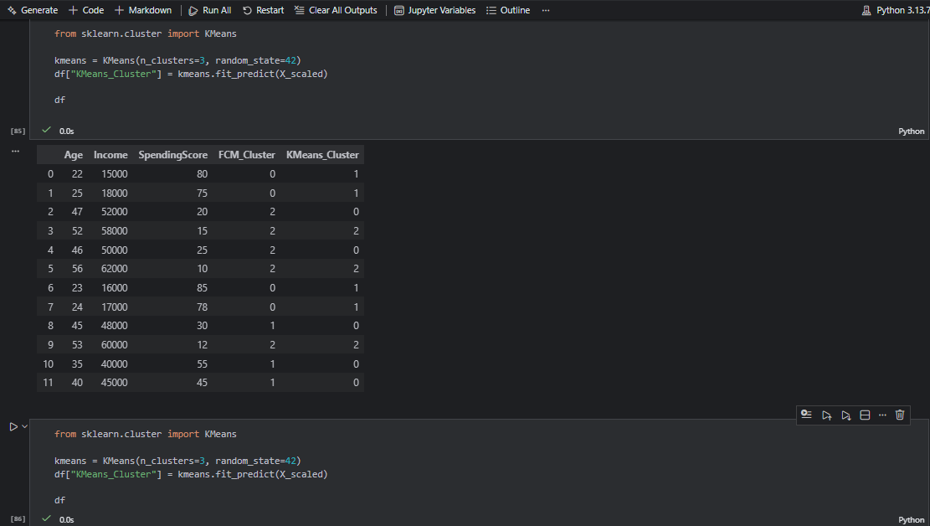
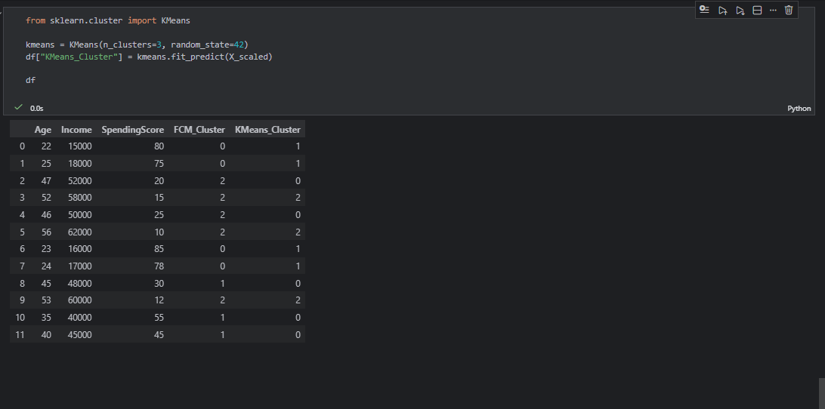

Question No. 5
(Dataset: Kaggle → “COVID-19 World Dataset”)
Task:
Cluster Pakistan and its neighboring countries based on COVID-19 indicators.
Questions:
- Select the countries:
  - Pakistan
  - India
  - China
  - Iran
  - Afghanistan
- Extract the following variables from the dataset:
  - Total Cases
  - Total Deaths
  - Population
- Normalize the selected features.
- Apply FCM with 2 clusters and report the cluster membership values.
- Show the final clusters for each country.
- Interpret results (e.g., high-impact vs. low-impact countries).
- Compute the FPC and discuss cluster quality.
- Compare FCM-based clustering with K-means clustering and comment on differences.
